**Q4. Select by ID**

Query all columns for a city in CITY with the ID 1661.

The CITY table is described as follows:

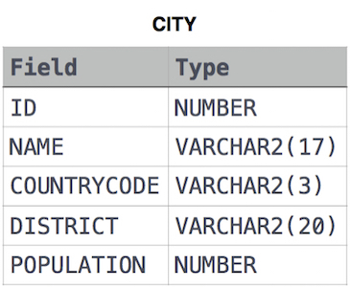

Ans.

SELECT *

FROM CITY

WHERE ID = 1661